Software Development Life Cycle

Introduction
Software development life cycle (SDLC) is important for the software project success, the good software engineer should have the enough experience and knowledge to prefer one model than another based on the project context.
Therefore, it may be required to choose the right SDLC model according to the specific concerns and requirements of the project.

Types of Software developing life cycles (SDLC)
- Waterfall Model
- Evolutionary Prototyping Model
- Spiral Method (SDM)
- Iterative and Incremental Method

Waterfall Model

Description
The waterfall Model is a linear sequential flow. In which progress is seen as flowing steadily downwards (like a waterfall) through the phases of software implementation. This means that any phase in the development process begins only if the previous phase is complete. The waterfall approach does not define the process to go back to the previous phase to handle changes in requirement. The waterfall approach is the earliest approach and most widely known that was used for software development.
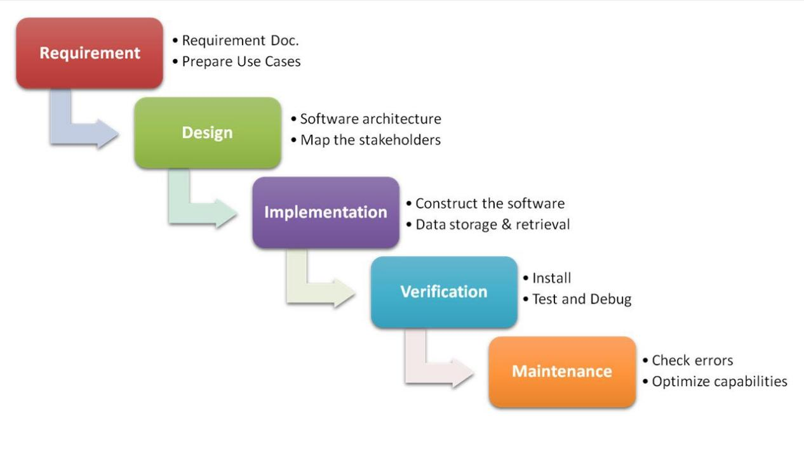

The usage
Projects which not focus on changing the requirements, for example, projects initiated from request for proposals (RFPs), the customer has a very clear documented requirements

Advantages and Disadvantages
Advantages | Disadvantages
- Easy to explain to the users.  - Structures approach.  - Stages and activities are well defined.  - Helps to plan and schedule the project.  - Verification at each stage ensures early detection of errors/misunderstanding.  - Each phase has specific deliverables. | - Assumes that the requirements of a system can be frozen.  - Very difficult to go back to any stage after it finished.  - A little flexibility and adjusting scope is difficult and expensive.  - Costly and required more time, in addition to the detailed plan.

Prototyping Model

Description
It refers to the activity of creating prototypes of software applications, for example, incomplete versions of the software program being developed. It is an activity that can occur in software development. It used to visualize some component of the software to limit the gap of misunderstanding the customer requirements by the development team. This also will reduce the iterations may occur in waterfall approach and hard to be implemented due to the inflexibility of the waterfall approach. So, when the final prototype is developed, the requirement is considered to be frozen.
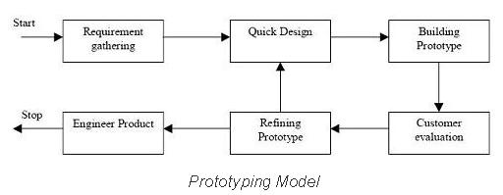
It has some types, such as:
- Throwaway prototyping: Prototypes that are eventually discarded rather than becoming a part of the finally delivered software
- Evolutionary prototyping: prototypes that evolve into the final system through an iterative incorporation of user feedback.
- Incremental prototyping: The final product is built as separate prototypes. At the end, the separate prototypes are merged in an overall design.
- Extreme prototyping: used at web applications mainly. Basically, it breaks down web development into three phases, each one based on the preceding one. The first phase is a static prototype that consists mainly of HTML pages. In the second phase, the screens are programmed and fully functional using a simulated services layer. In the third phase, the services are implemented

The usage
- This process can be used with any software developing life cycle model. While this shall be chosen when you are development a system has user interactions. So, if the system does not have user interactions, such as a system does some calculations shall not have prototypes.

Advantages and Disadvantages
Advantages | Disadvantages
- Reduced time and costs, but this can be a disadvantage if the developer loses time in developing the prototypes.  - Improved and increased user involvement. | - Insufficient analysis· User confusion of prototype and finished system.  - Developer misunderstanding of user objectives.  - Excessive development time of the prototype.  - Expense of implementing prototyping

Spiral Model (SDM)

Description
It is combining elements of both design and prototyping-in-stages, in an effort to combine advantages of top-down and bottom-up concepts. This model of development combines the features of the prototyping model and the waterfall model. The spiral model is favored for large, expensive, and complicated projects. This model uses many of the same phases as the waterfall model, in essentially the same order, separated by planning, risk assessment, and the building of prototypes and simulations.
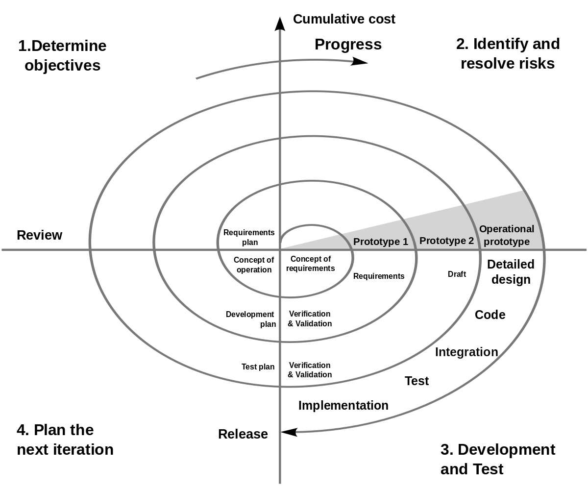

The usage
It is used in the large applications and systems which built-in small phases or segments.

Advantages and Disadvantages
Advantages | Disadvantages
- Estimates (i.e. budget, schedule, etc.) become more realistic as work progressed because important issues are discovered earlier.  - Early involvement of developers.  - Manages risks and develops the system into phases. | - High cost and time to reach the final product.  - Needs special skills to evaluate the risks and assumptions.  - Highly customized limiting re-usability

Iterative and Incremental Model

Description
It is developed to overcome the weaknesses of the waterfall model. It starts with an initial planning and ends with deployment with the cyclic interactions in between. The basic idea behind this method is to develop a system through repeated cycles (iterative) and in smaller portions at a time (incremental), allowing software developers to take advantage of what was learned during the development of earlier parts or versions of the system.
It consists of mini waterfalls
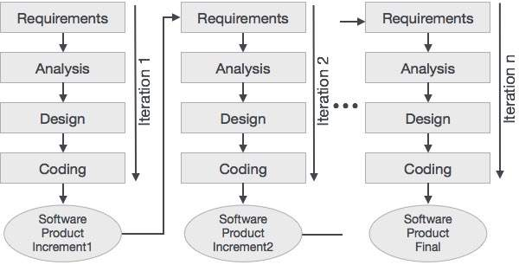

The usage
It is used in shrink-wrap application and large system which built-in small phases or segments. Also, can be used in a system has separated components, for example, ERP system. Which we can start with the budget module as a first iteration and then we can start with inventory module and so forth.

Advantages and Disadvantages
Advantages | Disadvantages
- Produces business value early in the development lifecycle.  - Better use of scarce resources through proper increment definition.  - Can accommodate some change requests between increments.  - More focused on customer value than the linear approaches.  - Problems can be detected earlier. | - Requires heavy documentation.  - Follows a defined set of processes.  - Defines increments based on function and feature dependencies.  - Requires more customer involvement than the linear approaches.  - Partitioning the functions and features might be problematic.  - Integration between iteration can be an issue if this is not considered during the development.

